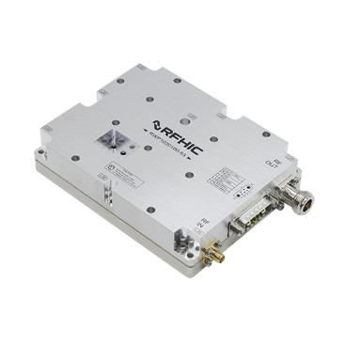
Product Features Applications

- GaN on SiC Broadband High Power Amplifier
- 1000 ~ 2000MHz Operation Bandwidth
- Power Gain 53dB @ Pin -3dBm
- 100W Minimum @ Pin -3dBm

Description
- Aerospace & Defense
- Military
- Electronic Warfare
- Rader
- SATCOM
- Communication
- EMI/RFI
- Jamming

The power amplifier module is designed for Broadcasting, Telecommunication, Medical and Other markets. Operating frequency range is from 1000 ~ 2000MHz.
Gallium Nitride on SiC technology is used and attached on an aluminum sub carrier. Full in/out matching for broadband performance is already applied.
Improved thermal handling by patented technology.

Electrical Specifications @ VCC = 36V; Tc = 45°C; ZS = ZL = 50Ω

PARAMETER | UNIT | MIN | TYP | MAX | CONDITION
Operating Frequency | MHz | 1000 | - | 2000 | -
Power Gain @ Pin -3dBm | dB | 53 | 53.8 | - | 1000 ~ 2000MHz
Power Gain Flatness @ Pin -3dBm | dBpp | - | ±1.0 | ±2.0 | 1000 ~ 2000MHz
Output Power @ Pin -3dBm | dBm | 50 | 50.8 | - | 1000 ~ 2000MHz
Third-Order Intercept Point(OIP3)  2-Tone @ 40dBm/Tone, 1MHz Spacing | dBm | 48 | 55
Input Return Loss | dB | - | -9 | -5 | -
Supply Voltage | V | 35.5 | 36.0 | - | Vcc(=Vds)
Quiescent Current consumption | A | - | 4.0 | 4.4 | -
Current Consumption @ Pin -3dBm | A | - | 9 | 12 | CW 1-tone

Absolute Maximum Ratings

PARAMETER | UNIT | RATING
Input RF Power | dBm | 0
Supply Voltage | V | 37
Load Mismatch Value | - | 3 : 1 @all load phase
* Input Signal Condition : CW 1-Tone

Environmental Characteristics

PARAMETER | UNIT | MIN | TYP | MAX | SYMBOL
Operating Flange Temperature | °C | -40 | - | 85 | Tc
Storage Temperature | °C | -40 | - | 105 | Tstg
Vibration | MIL-STD-810G Method 514.6 ANNEX C |  |  |  | VI

Mechanical Specifications

PARAMETER | UNIT | TYP
Dimension | ㎜ | 134(L) x 105(W) x 30(H)
Weight | g | 635
RF Connector | - | RF Input : SMA Female
RF Connector | - | RF Output : N-Type Female
DC Connector | - | C7W2 / D-SUB / Male type
Cooling | - | External Heat-sink

Typical Performance @ 45°C

Frequency | RF IN | RF OUT [POUT]
MHz | dBm | WATT | Current[A] | EFF[%]
1000 | -9.0 | 100 | 8.07 | 34.42
1100 | -10.3 | 100 | 7.30 | 38.05
1200 | -11.1 | 100 | 6.60 | 42.09
1300 | -12.5 | 100 | 6.34 | 43.81
1400 | -12.6 | 100 | 6.70 | 41.46
1500 | -10.4 | 100 | 7.54 | 36.84
1600 | -9.3 | 100 | 7.94 | 34.98
1700 | -8.0 | 100 | 8.37 | 33.19
1800 | -8.3 | 100 | 8.43 | 32.95
1900 | -10.4 | 100 | 8.07 | 34.42
2000 | -10.7 | 100 | 8.75 | 31.75
< Chart1. 100Watt POUT >

Frequency | RF IN | RF OUT [PSAT]
MHz | dBm | dBm | WATT | Current[A] | EFF[%]
1000 | -3.0 | 51.86 | 153.5 | 10.42 | 40.91
1100 | -3.0 | 52.26 | 168.3 | 9.85 | 47.45
1200 | -3.0 | 51.94 | 156.3 | 8.64 | 50.26
1300 | -3.0 | 51.61 | 144.9 | 7.75 | 51.93
1400 | -3.0 | 52.17 | 164.8 | 8.77 | 52.20
1500 | -3.0 | 51.53 | 142.2 | 9.24 | 42.76
1600 | -3.0 | 51.72 | 148.6 | 9.68 | 42.64
1700 | -3.0 | 51.57 | 143.5 | 10.19 | 39.13
1800 | -3.0 | 51.36 | 136.8 | 10.20 | 37.25
1900 | -3.0 | 51.67 | 146.9 | 10.20 | 40.00
2000 | -3.0 | 51.43 | 139.0 | 10.65 | 36.25
< Chart2. PSAT >

Frequency | Power Monitor
MHz | dBm | V | dBm | V
1000 | 48 | 0.895 | 50 | 0.840
1100 | 48 | 0.878 | 50 | 0.832
1200 | 48 | 0.874 | 50 | 0.819
1300 | 48 | 0.839 | 50 | 0.787
1400 | 48 | 0.839 | 50 | 0.788
1500 | 48 | 0.826 | 50 | 0.775
1600 | 48 | 0.814 | 50 | 0.768
1700 | 48 | 0.804 | 50 | 0.754
1800 | 48 | 0.798 | 50 | 0.747
1900 | 48 | 0.789 | 50 | 0.735
2000 | 48 | 0.794 | 50 | 0.745
<Chart3. Power Monitor>

< Chart4. PSAT Vs EFFICIENCY(Plot) >

< Chart5. Power Monitor(Plot) >

Precautions
- This product is designed to be used for broadband amplification. Heat generation is higher when there is RF signal in the device. Therefore, the worst case scenario is when there is RF signal.
The temperature must be calculated properly. Case temperature must maintain below 70°C.
- Thermal Grease or Metal Thermal Interface Materials are recommended for heat dissipation. An example would be spreading thermal grease on the bottom of the device.

Package Dimensions

* Unit: mm[inch] | Tolerance: ±0.3[.012]
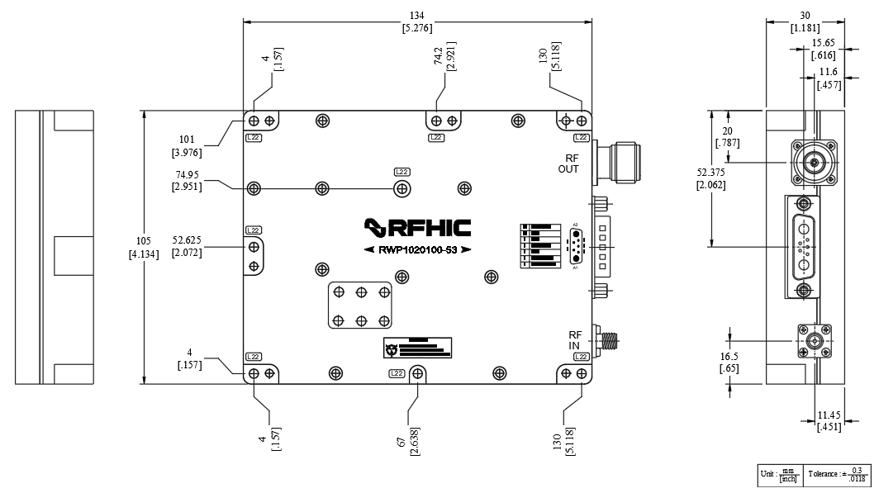

Pin Description ( C7W2 / D-SUB / Male type )
Pin No | Description | I/O | Specifications
A1 | Vcc | I | +36VDC
A2 | GND | I | Ground
1 | GND | I | Ground
2 | HPA Enable | I | Enable : TTL “High”, Disable : TTL “Low” (Low : 0 ~ 1.0V, High : 4.0 ~ 5.0V)  Disable Status : 150mA Current consumption  (Turn ON Delay Time : 450mS Max)
3 | GND | I | Ground
4 | Temperature Monitor | O | Reference voltage : 750mV @ 25℃
5 | Power Monitor | O | Pout 48dBm Voltage : 700 ~ 1000mV
* Recommended Screw Torque : 8.0kgf.cm±1 using SEMS M3 22mm Bolt

Revision History

Part Number | Release Date | Version | Modification | Data Sheet Status
RWP1020100-53 | 2024.02.14 | 0.1 |  | -
RWP1020100-53 | 2024.02.22 | 0.2 | Change the Shut Down method (High -> Low) | -
RWP1020100-53 | 2024.02.23 | 0.3 | Shut Down -> HPA Enable  Package Dimensions & Picture Update
RWP1020100-53 | 2024.05.10 | 1.0 | Chart, Package Dimensions Update
RWP1020100-53 | 2024.08.20 | 1.1 | Quiescent Current Consumption | 1.5A / 2.0A -> 4.0A / 4.4A
RWP1020100-53 | 2024.09.03 | 1.2 | OIP3 Compliance

 | Certification  This product is manufactured by a company that is certified for the AS9100D quality management system.

RFHIC Corporation reserves the right to make changes to any products herein or to discontinue any product at any time without notice. While product specifications have been thoroughly examined for reliability, RFHIC Corporation strongly recommends buyers to verify that the information they are using is accurate before ordering. RFHIC Corporation does not assume any liability for the suitability of its products for any particular purpose, and disclaims any and all liability, including without limitation consequential or incidental damages. RFHIC products are not intended for use in life support equipment or application where malfunction of the product can be expected to result in personal injury or death. Buyer uses or sells such products for any such unintended or unauthorized application, buyer shall indemnify, protect, and hold RFHIC Corporation and its directors, officers, stockholders, employees, representatives and distributors harmless against any and all claims arising out of such unauthorized use. All sales inquiries and support should be directed to the local authorized geographic distributor for RFHIC Corporation. For customers in the US, please contact the US sales team through our website at https://rfhic.com/rfhic-us/. For all other inquiries, please contact our international sales team through our website portal at https://rfhic.com/contact/

